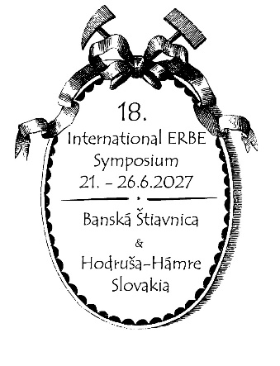
18th International Symposium/18. ERBE - Symposium
Cultural Heritage in Geosciences, Mining and Metallurgy
Libraries - Archives - Museums
21st- 26thJune 2027, Banská Štiavnica, Hodruša-Hámre, Slovakia

First CIRCULAR
Topics:
- The 400th anniversary of the first documented blasting in a mine
- Preservation and presentation of the historical heritage of mining and metallurgy
- New ways to make collections accessible – digitization
- Various other topics
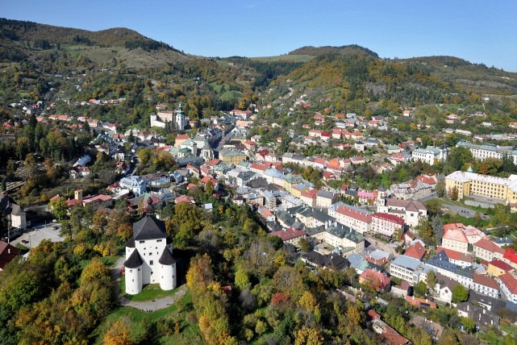

Main organizers:
Slovenský banský archív v Banskej Štiavnici (Slovak Mining Archive in Banská Štiavnica)
Slovenské banské múzeum, Banská Štiavnica (Slovak Mining Museum, Banská Štiavnica)

Other organizers:
Mesto Banská Štiavnica, Obec Hodruša-Hámre, Banskoštiavnicko-hodrušský banícky spolok, Slovenská banská, spol. s r. o. – Expozícia Baňa Starovšechsvätých, Banskobystrický samosprávny kraj

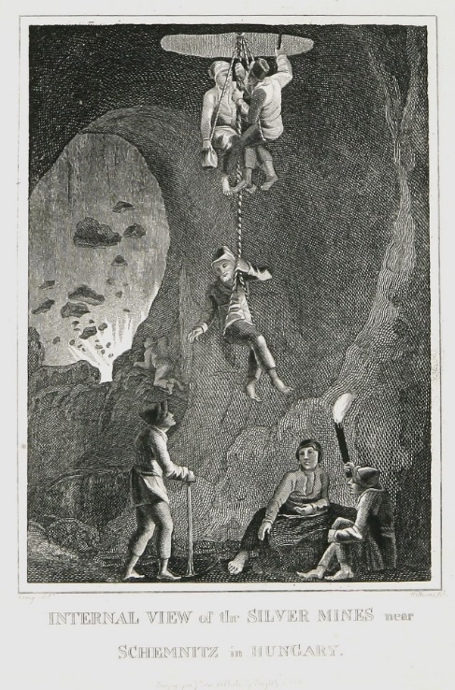

Local organizing committee:
Peter KONEČNÝ, Slovak Mining Archive
Katarína OLAJCOVÁ, Slovak Mining Archive
Lukáš PATERA, Slovak Mining Museum
Daniel HARVAN, Slovak Mining Museum
Emília ŠVECOVÁ, Slovak Mining Museum
Slavomír MICHNA, Slovak Mining Museum
Richard KAŇA, Slovenská banská s.r.o – The Old All Saints Mine in Hodruša-Hámre
Karol WEIS, Banská Štiavnica and Hodruša Miners’ Association
Jozef LABUDA, Banská Štiavnica and Hodruša Miners’ Association
Erik SOMBATHY, Slovak Union of Miners’ Associations and Miners’ Guilds

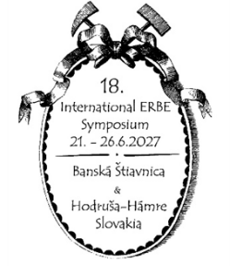
18th International Symposium/18. ERBE - Symposium
Cultural Heritage in Geosciences, Mining and Metallurgy
Libraries - Archives - Museums
21st- 26thJune 2027, Banská Štiavnica, Hodruša-Hámre, Slovakia

Preliminary program information: June 21–26, 2027

June 21–25 (Monday–Friday): Paper presentations at Salamandra Resort Hotel, Hodruša-Hámre
Every afternoon after morning lectures, field trips to:
- The historic center of Banská Štiavnica
- Slovak Mining Archive, Slovak Mining Museum
- Nová Baňa – Pohronské Museum in Nová Baňa, Althandel
- Kremnica – Museum of Coins and Medals, Mint
- Hodruša-Hámre – The Old All Saints Mine, Rozália Mine, evening program

June 26 (Saturday): excursion to the mining and geological exposition at Starovšechsvätých (The Old All Saints) Mine in Hodruša-Hámre, followed by refreshments

Accommodation options:
Given that the symposium takes place at the Salamandra Resort, we recommend booking your accommodation at this hotel. You can find other accommodation options in the region at www.booking.com.

Nearby airports:
BTS - M. R. Stefanik Airport/Bratislava – Slovakia
VIE - Schwechat Airport/Vienna – Austria
BUD - Ferenc Liszt International Airport /Budapest – Hungary
PRG - Vaclav Havel Airport /Prague – Czech Republic
KRK - John Paul II International Airport /Kraków – Poland

Additional information:
Overview of previous symposia:
- 1993 Freiberg/Sachsen, Germany
- 1995 Leoben, Austria
- 1997 St. Petersbug, Russia
- 1998 Banská Štiavnica, Slovakia
- 2000 Golden, Colorado, USA
- 2002 Idrija, Slovenia
- 2003 Leiden, Netherlands
- 2005 Schwaz, Austria
- 2007 Quebec, Quebec, Canada
- 2009 Freiberg/Sachsen, Germany
- 2011 Mexico-City, Pachuca, Real
del Monte, Mexico
- 2013 Bozen/Bolzano, Italy
- 2015 Banská Štiavnica, Slovakia
- 2018 Ravne na Koroškem, Slovenia
- 2021 Eggenburg, Austria
- 2023 Freiberg/Sachsen, Germany
- 2025 Ravne na Koroškem, Slovenia

Registration and fees:
Those interested in further information about the 18th International ERBE Symposium, including registration and the lecture program, may send their questions by email.

Registration fee for the symposium on June 21–26, 2027, including registration, printed materials, and refreshments: 140 € (students: 100 €). Lunches, accommodation and museum visits are not included in the conference fee.

Contact: peterkonecnyerbe@gmail.com

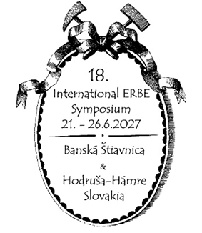
18th International Symposium/18. ERBE - Symposium
Cultural Heritage in Geosciences, Mining and Metallurgy
Libraries - Archives - Museums
21st- 26thJune 2027, Banská Štiavnica, Hodruša-Hámre, Slovakia

Participation in the 18th International ERBE Symposium

Academic degree ..........................................................................................................
First Name ..........................................................................................................
Surname ..........................................................................................................
Institution ..........................................................................................................
Address ..........................................................................................................
Phone number ..........................................................................................................
E-mail ..........................................................................................................
Provisional title of your paper ..........................................................................................................
..........................................................................................................

I'll probably attend

I request for additional information
1111
No presentation

Oral presentation

Poster presentation

I am a student

I am interested in participating in the upcoming field trips in the region

I will be accompanying a person who has registered for the symposium

I will send the abstract in the following language:
English mandatory (~3000 chrs.)
xxxxx
German

Slovak

Another language ..................................

Deadline for submitting paper and poster proposals: September 30, 2026
Deadline for submitting abstracts: September 30, 2026
The second circular distribution by December 20, 2026

Contact:
Mgr. Peter Konečný, PhD.
Slovenský banský archív
Radničné nám. 16
969 01 Banská Štiavnica, Slovakia peterkonecnyerbe@gmail.com
Phone numbers: +421-45-67 00 214, +421-45-67 00 228
e-mail: erbe.symposium@gmail.com
web.: www.muzeumbs.sk
www.erbe-symposium.org

